Venezia Catamaran Gift Card Templates

Create your own gift card(s) using the below editable templates.
More instructions and comments at the end of this document

Template 1: Sunset Jazz Cruise for 2 persons. Value 160 Euro
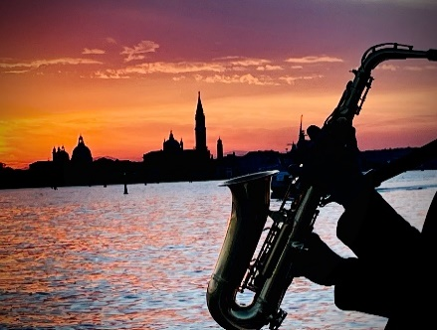
Venezia Catamaran Gift Card
Voucher No GC-xxxxxxx
Venezia Catamaran “Sunset Jazz Cruise” for 2 persons
To be converted into a valid ticket until 31/10/2022
Value 160 EUR

How to obtain your ticket
- Scan the QR Code on this voucher or go to www.venezia-cat.it
- Choose your tour, pax and date and go to Checkout
- Enter the above Voucher No. and complete the booking process

Romantic sunset over Venice
Live Jazz Saxophone
Incl. Venetian cicchetti & open bar!

Template 2: Venice by Night Cruise for 2 persons. Value 120 Euro
Venezia Catamaran Gift Card
Voucher No GC-xxxxxxx
Venezia Catamaran “Venice by Night Cruise” for 2 persons
To be converted into a valid ticket until 31/10/2022

How to obtain your ticket
- Scan the QR Code on this voucher or go to www.venezia-cat.it
- Choose your tour, pax and date and go to Checkout
- Enter the above Voucher No. and complete the booking process

90 min cruise in the Venetian lagoon
on spacious and exclusive catamaran.
Live Jazz Saxophone

Template 3: Vivaldi Cruise for 2 persons. Value 80 Euro
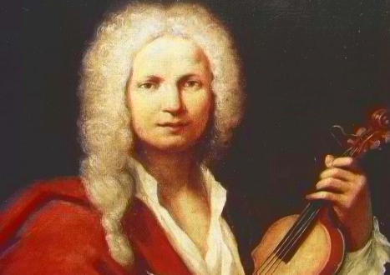
Venezia Catamaran Gift Card
Voucher No GC-xxxxxxx
Venezia Catamaran “Vivaldi Cruise” for 2 persons
To be converted into a valid ticket until 31/10/2022

How to obtain your ticket
- Scan the QR Code on this voucher or go to www.venezia-cat.it
- Choose your tour, pax and date and go to Checkout
- Enter the above Voucher No. and complete the booking process

90 min cruise in the Venetian lagoon
on spacious and exclusive catamaran to the music of Vivaldi, Bach, Chopin ..

Template 4: Spritz Tour for 2 persons. Value 80 Euro
Venezia Catamaran Gift Card
Voucher No GC-xxxxxxx
Venezia Catamaran “Spritz Tour” for 2 persons
To be converted into a valid ticket until 31/10/2022

How to obtain your ticket
- Scan the QR Code on this voucher or go to www.venezia-cat.it
- Choose your tour, pax and date and go to Checkout
- Enter the above Voucher No. and complete the booking process

90 min cruise in the Venetian lagoon
on spacious and exclusive catamaran.
Ample choice of drinks included

Template 5: Value Voucher for 200 Euro
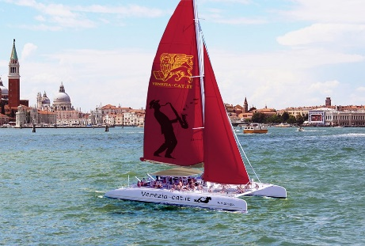
Venezia Catamaran Gift Card
Voucher No GC-xxxxxxx
Venezia Catamaran Cruises. value 200 EUR
To be converted into a valid ticket until 31/10/2022

How to obtain your ticket
- Scan the QR Code on this voucher or go to www.venezia-cat.it
- Choose your tour, pax and date and go to Checkout
- Enter the above Voucher No. and complete the booking process
- Voucher code may be used for multiple bookings

90 min cruise in the Venetian lagoon
on spacious and exclusive catamaran.
Ample choice of drinks included

How to Use Venezia Catamaran Gift Cards

- Create Your own Gift Card Template
Based on this editable word file, create your own template. You may want to change the text, translate the voucher to other languages, or add your own company logo.
- Purchase one or more gift vouchers online
On www.venezia-cat.it/GiftCard, you can generate any value which is a multiple of 40 or 60 Euro. After completion of the purchase, you will receive a ticket with the Voucher Code:
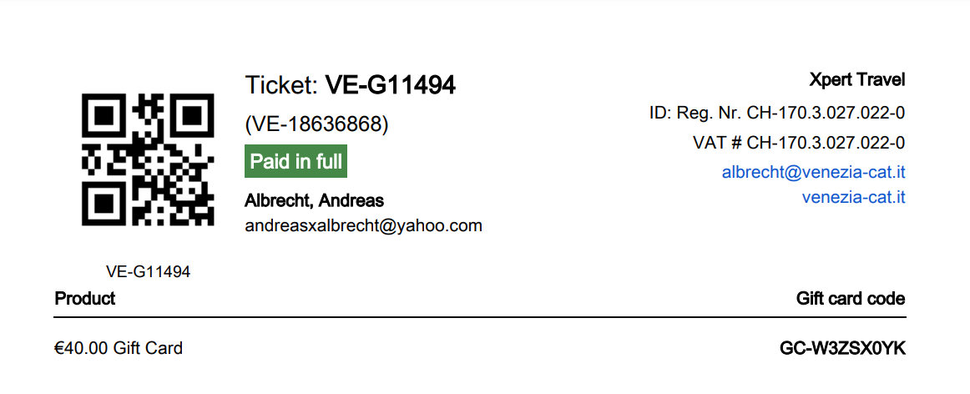
- Create your personalized Gift Card with Gift Card Code
Add the above Gift Card code to your template to create your gift card. You may also want to add the name of the person or organization that is to receive this gift card.
- Send Your Gift Card
Print your gift cards on quality paper or send them as picture via email… just make sure that your gift card contains the correct gift card code and clear instructions how to redeem the ticket.

Important Note
Whatever your choice of voucher and the wording of your gift card, our vouchers are NOT linked to any specific tour but can be used in the most flexible way for ALL Venezia catamaran products. It is also possible to use the voucher for multiple tours on different dates.
Example: A gift voucher for 2 x Sunset Jazz Cruise in the value of 160 EUR could be used as follows:
- Buy two tickets for the Sunset Jazz Cruise
- Buy four tickets for the Vivaldi tour
- Buy two tickets for the Vivaldi Tour and two tickets for the Spritz Tour at a later date, using the same voucher code
- Buy three tickets for the Sunset Jazz Cruise, whereby two tickets are free, one ticket needs to be paid
Venice, 8 August 2022

